Assignment: Modeling Software Processes in Visio

**Objectives:**

* Review the Waterfall, Prototype Evolution, Spiral, Generic Agile, and SCRUM processes.
* Practice using a CASE tool (Computer-Aided Software Engineering tool), Microsoft Visio, to create activity diagrams.

**Preparation:**

For Windows users, please follow the instructions below and install Visio 2019, and use it to model software processes (in the format of activity diagram).

For Mac users, you may use Omnigraffle if you have it installed already, or you may use any Windows lab machine at Riverside Hall to complete this assignment.

**Visio 2016/2019 Installation:**

Please log into your ECS portal: <https://www.ecs.csus.edu/index.php?content=ecs_portal>, and visit MSDN Academic Alliance site. Download and install Visio 2016/2019 (either version is fine).

**Using Visio 2016/2019**

Launch Visio 2016/2019, and you will see the following screen:

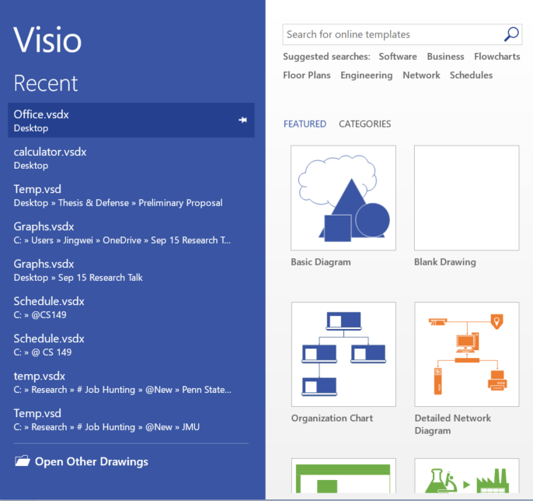 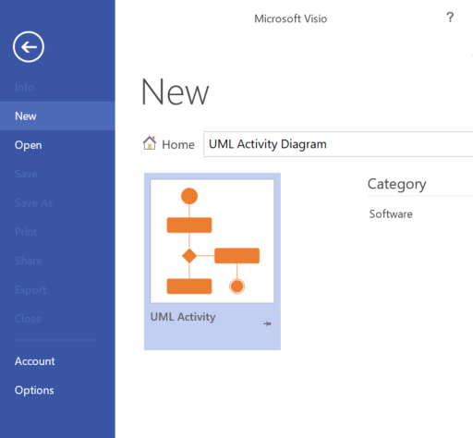 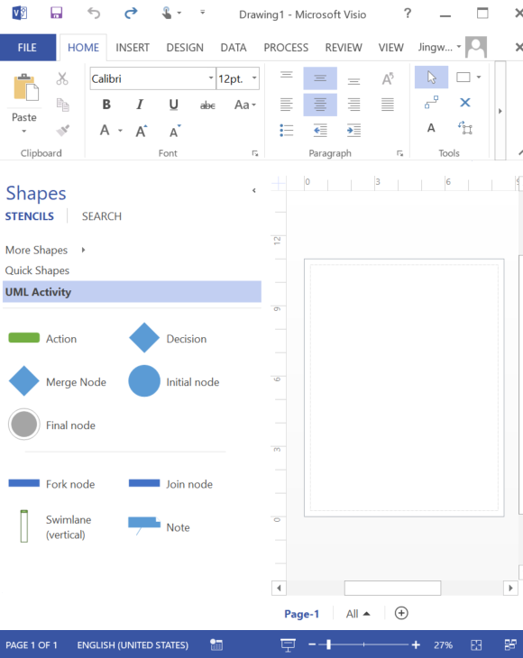

In the top search bar, search for “UML Activity Diagram”, then you will see the corresponding template. Once you select the template, the basic elements of activity diagram will be available on the left menu. Note that there may be some missing elements, for example, “Activity” (the big rectangular to represent the activity itself). You may draw those missing elements using basic shapes that are available under tab “Quick Shapes”.

**Deliverable:**

Refer to Week03 reading materials and slides, and use **Visio** to create a model (activity diagram) for the **Waterfall**, **Prototype Evolution**, **Spiral**, **Generic Agile**, and **SCRUM** process respectively. Add all five models into a PDF file and submit it through Canvas.

Note: You may create exactly the same models as it is shown in the reading materials, or you may try to create those models based on your own understanding. The key is to meet all of the objectives of this assignment.